EXPT NO: 2 | COMPARATIVE STUDY OF ACTIVATION FUNCTIONS AND OPTIMIZATION ALGORITHMS IN DEEP LEARNING
DATE: 22/07/2026

PRE-LAB QUESTIONS (PROVIDE BRIEF ANSWERS TO THE FOLLOWING QUESTIONS)

- What is the purpose of an activation function in an Artificial Neural Network?
An activation function introduces non-linearity into the neural network, allowing it to learn complex patterns and relationships in data. Without it, the network would behave like a simple linear model.
- Differentiate between the Sigmoid, Tanh, and ReLU activation functions based on their output range and mathematical properties.
Activation Function | Output Range | Mathematical Property
Sigmoid | 0 to 1 | Smooth function, used for binary classification, outputs probabilities.
Tanh | -1 to 1 | Zero-centered, learns faster than Sigmoid in many cases.
ReLU | 0 to ∞ | Outputs 0 for negative values and the input for positive values, simple and computationally efficient.

- Why is an optimization algorithm required during neural network training?
An optimization algorithm updates the network's weights to minimize the loss function, helping the model learn from the training data and improve prediction accuracy.

- What is the difference between Batch Gradient Descent, Stochastic Gradient Descent (SGD), and Mini-Batch Gradient Descent?

• Batch Gradient Descent: Uses the entire dataset to update weights after each iteration.
• Stochastic Gradient Descent (SGD): Updates weights after processing each training sample, making learning faster but noisier.
• Mini-Batch Gradient Descent: Updates weights after processing a small batch of samples, providing a balance between speed and stability.

- Explain the role of Google Colab and GitHub in deep learning experiment management.

• Google Colab: Provides a cloud-based environment to write and run Python code with free GPU/TPU support, making deep learning experiments easy to perform.
• GitHub: Stores and manages code using version control, allowing users to track changes, collaborate, and share deep learning projects.

AIM
To analyze the impact of different activation functions and optimization algorithms on the performance of Artificial Neural Networks (ANNs) and to learn best practices for managing deep learning experiments using cloud-based tools and version control.

SOFTWARE REQUIREMENTS
- Python
- TensorFlow or PyTorch
- Google Colab
- GitHub
- Matplotlib

OBJECTIVES
Students will be able to:
- Understand the role of activation functions in neural networks.
- Visualize and compare commonly used activation functions.
- Evaluate the performance of different activation functions in ANN models.
- Analyze various gradient-based optimization algorithms.
- Compare optimizer convergence and model accuracy.
- Learn experiment management using Google Colab, Google Drive, and GitHub.
- Maintain reproducible deep learning experiments using version control.

PROCEDURE
PART A: VISUALIZATION OF ACTIVATION FUNCTIONS
Implement and plot the following activation functions:
- Sigmoid
- Tanh
- ReLU
Compare their:
- Output range
- Saturation regions
- Gradient behavior
- Computational efficiency
- Typical applications

CODE:
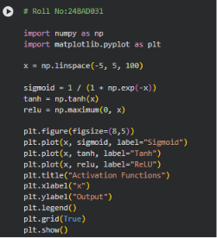

OUTPUT:
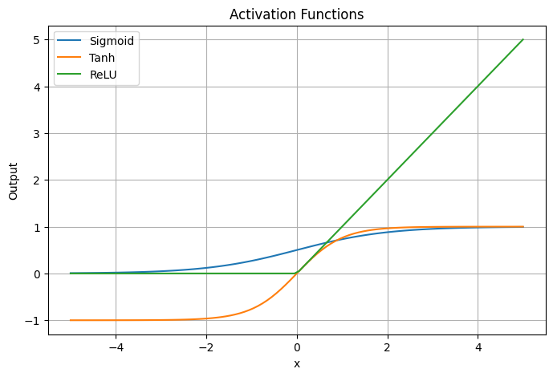
PART B: PERFORMANCE COMPARISON OF ACTIVATION FUNCTIONS
Train identical ANN architectures using:
- Sigmoid
- Tanh
- ReLU
Record and compare:
- Training accuracy
- Validation accuracy
- Training loss
- Validation loss
- Number of epochs required for convergence
Analyze which activation function performs best and justify the observations.

CODE:
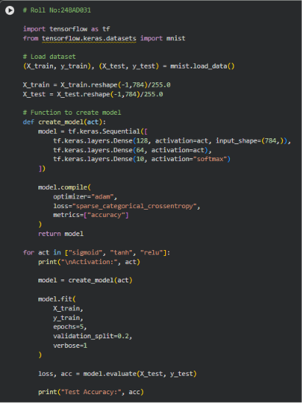
OUTPUT:
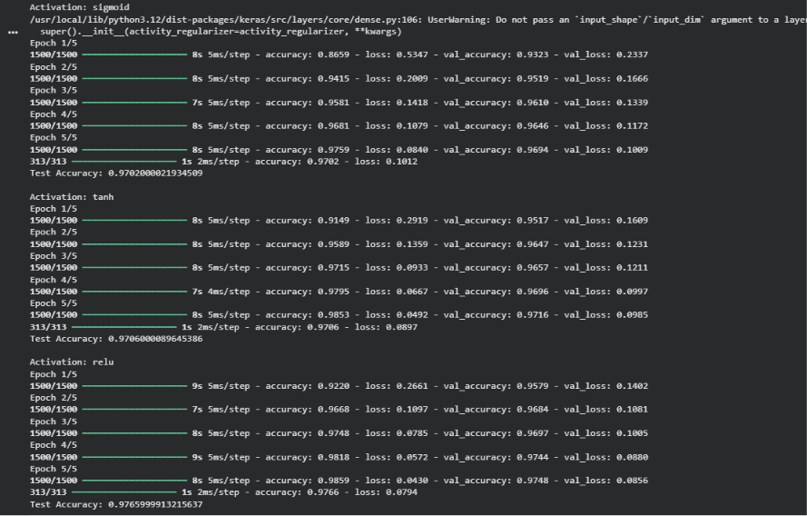

PART C: COMPARISON OF OPTIMIZATION ALGORITHMS
Train the same ANN using:
- Stochastic Gradient Descent (SGD)
- Momentum
- RMSProp
- Adam
Compare:
- Training loss
- Validation loss
- Convergence speed
- Final training accuracy
- Final validation accuracy
Visualize:
- Loss vs Epoch
- Accuracy vs Epoch
Discuss which optimizer converges faster and produces better generalization.

CODE:
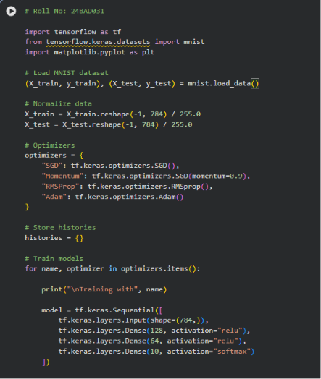
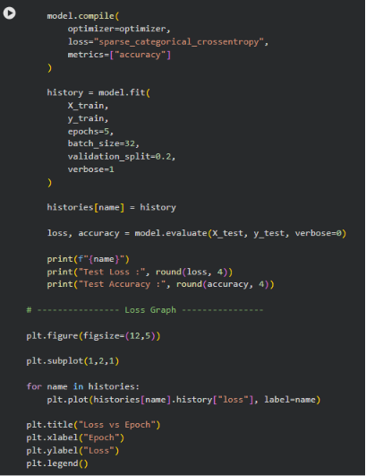
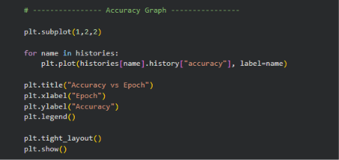

OUTPUT:

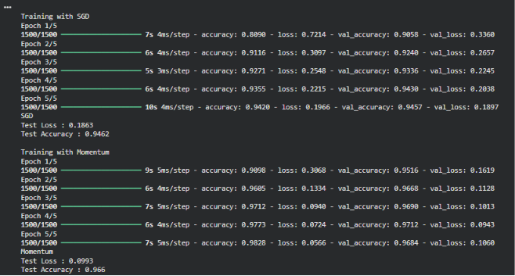
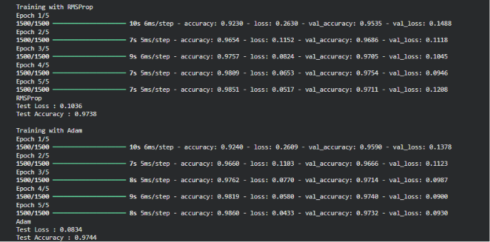
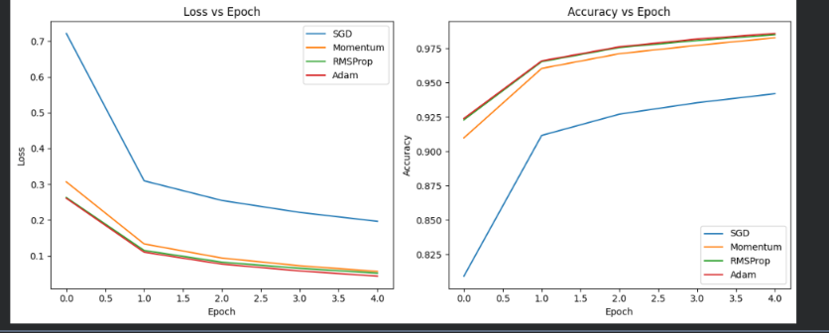
PART D: DEEP LEARNING EXPERIMENT MANAGEMENT
Perform the following tasks:
- Create a Google Colab notebook.
- Mount Google Drive.
- Save notebooks and trained models.
- Create a GitHub repository.
- Upload notebooks to GitHub.
- Commit changes and maintain version history using Git.
- Document the experiment using a README.md file.

(CODE: CONATAINS STUDENT ROLL NOS
SCREENSHOT OF CODE
SCREENSHOT OF OUTPUT)

EXPECTED OUTCOME
Students will understand how activation functions and optimization algorithms influence neural network learning and performance. They will also gain practical experience in organizing, documenting, and maintaining reproducible deep learning experiments using cloud platforms and Git-based version control.

POST-LAB QUESTIONS (PROVIDE BRIEF ANSWERS TO THE FOLLOWING QUESTIONS)

- Which activation function achieved the best performance in your experiment? Justify your answer using the obtained results.
ReLU achieved the best performance because it converged faster, produced lower training loss, and achieved higher accuracy compared to Sigmoid and Tanh.
- Compare the convergence behavior of SGD, Momentum, RMSProp, and Adam based on the training graphs.

• SGD: Slow convergence and more fluctuations.
• Momentum: Faster and smoother convergence than SGD.
• RMSProp: Converges quickly by adapting the learning rate.
• Adam: Fastest and most stable convergence with the lowest loss.

- Why does the ReLU activation function generally train faster than the Sigmoid activation function?
ReLU trains faster because it is computationally simple and reduces the vanishing gradient problem, allowing gradients to flow more effectively during backpropagation.
- How does version control using GitHub improve the reproducibility and collaboration of deep learning projects?
GitHub stores code changes, tracks different versions, and allows multiple users to collaborate efficiently. It also helps reproduce experiments by maintaining a complete history of the project.

- If you were asked to train a deep neural network for an image classification task, which activation function and optimizer would you choose? Justify your selection based on the experimental observations.
I would choose ReLU as the activation function and Adam as the optimizer because they provide faster training, stable convergence, and better accuracy, making them well suited for image classification tasks.

ASSESSMENT
Description | Max Marks | Marks Awarded
Pre Lab Exercise | 5
In Lab Exercise | 10
Post Lab Exercise | 5
Viva | 10
Total | 30
Faculty Signature

